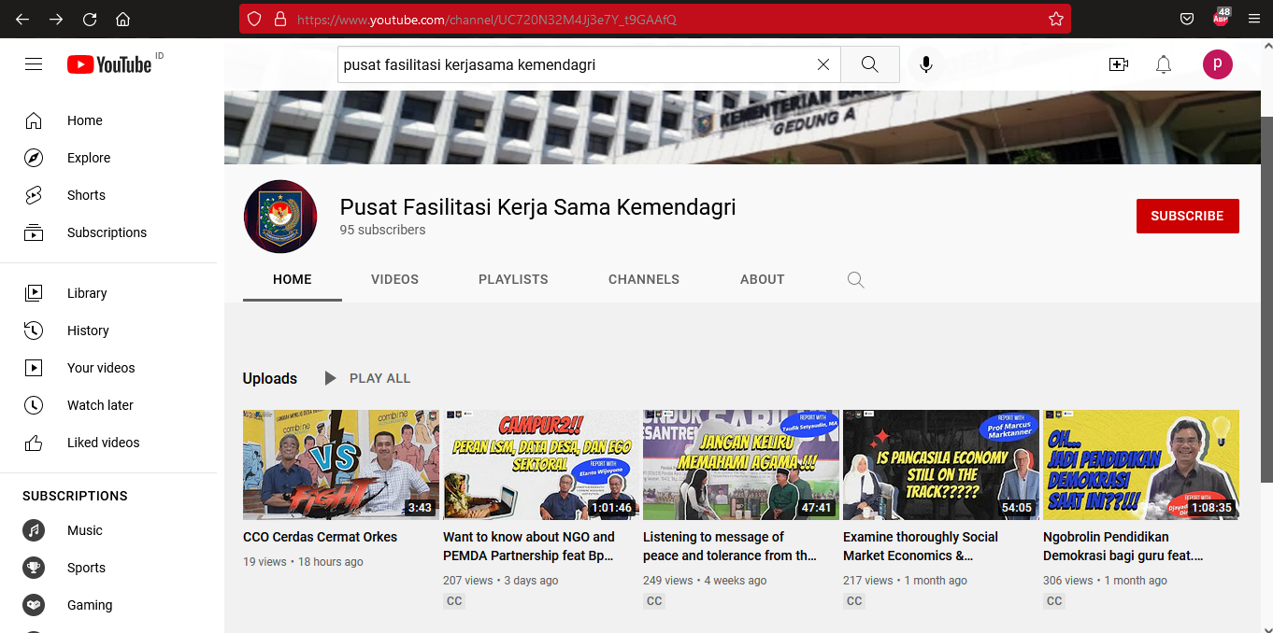
Link YouTube:
https://www.youtube.com/channel/UC720N32M4Jj3e7Y_t9GAAfQ?app=desktop

